**上海交通大学 密西根学院**

**ENGR4901J/4902J/4903J本科科研课程 结题报告**

**单独工作报告**

**UM-SJTU Joint Institute**

**ENGR4901J/4902J/4903J Undergraduate Research Course Final Report**

**INDIVIDUAL CONTRIBUTION REPORT**

Student Name：Feng Ying

Student ID Number：522051910119

Major: ECE

Project Title: Reinforcement Learning and supervised learning for efficient diabetes glucose prediction and control

Instructor: Yifei Zhu

In this project, my primary role involves adapting the glucose-insulin dynamic system from Mohammad et al.'s study to better align with data from Chinese diabetes patients (2022). This dynamic system includes several parameters that reflect the physiological conditions of patients. My task is to refine these parameters using the parameter estimation method for dynamic systems introduced by Attila and Julio, applying it specifically to a dataset of Chinese diabetes patients (2015).

At the beginning, I read Mohammad et al.’s article, where the glucose-insulin dynamic system in brought up shown in eq.1 to eq.5 (2022).

Where

In the article, the values of parameters are exhibited in fig.1

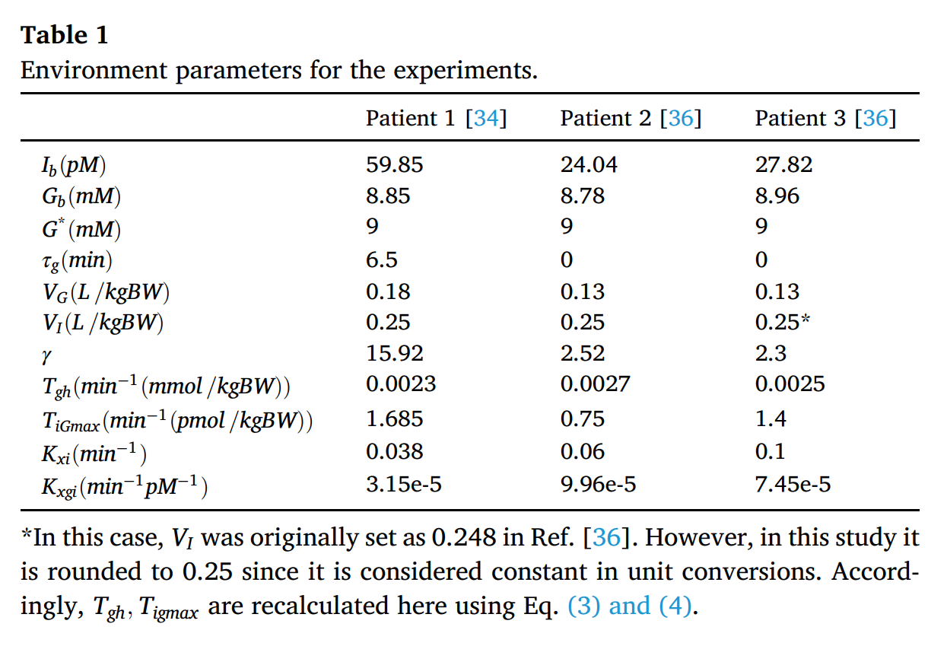

Fig.1 Values of Parameters

However, since these parameters are modified by the values of healthy people, they might be inaccurate. Additionally, the experiments of the database were conducted on foreigners, so they might not fit Chinese people’s conditions. Consequently, my idea is to modify the values of parameters using Shanghai Type-2 Diabetes Dataset so that the model can better simulate situations of Chinese patients.

Subsequently, I read Attila and Julio’s article, where the process of optimizing parameters in dynamic system is described concretely (2015). I then apply the approach to the glucose-insulin system and build up the model with the approach to optimize. The process of the parameter optimization process is exhibited in fig.2.

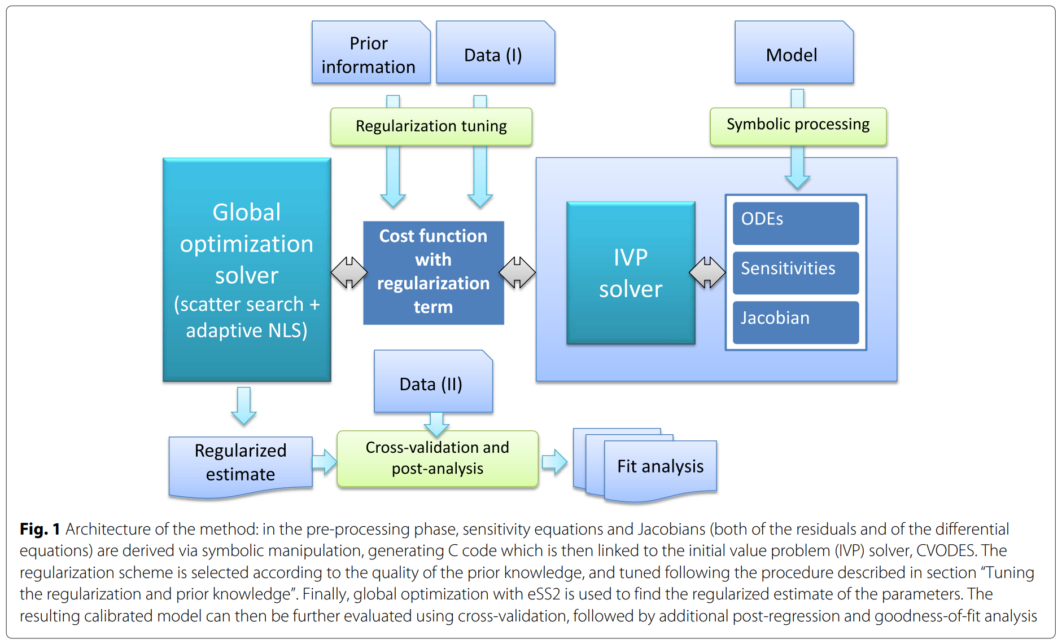

Fig.2 The Process of Parameter Optimization

The model here represents the glucose-insulin system, whose functions are shown before. Then, with the predicted glucose level which is the solution of the glucose-insulin system, I calculated the absolute difference between the predicted value and the measured one from the dataset as the cost function. Additionally, a regularization term is added to predict overfit. Finally, a minimize function is called to minimize the cost function and find out the optimal parameter values. The related code is shown in Appendix.

However, in the first version of my prediction, I ignored the influence of meal plan on the sudden glucose level change.

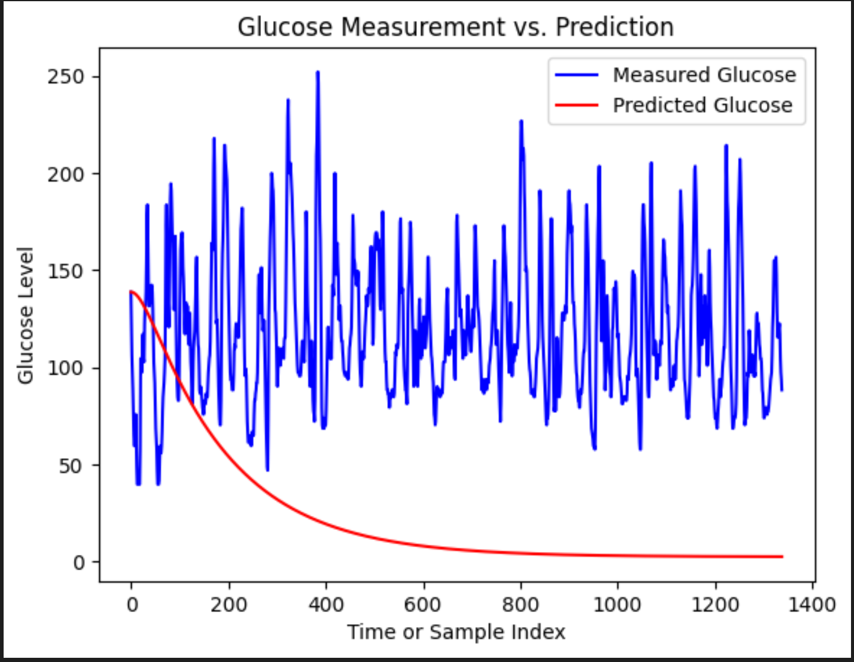

Fig.3 1st version Model Prediction Effect

As shown in Fig.3, the predicted glucose level continued to decrease, however in the actual situation, the value is jumping up and down, which is mainly caused by the meal plana.

To solve this problem, I try to add meal plans into the model. First, I divide the dataset by the meal time. Subsequently, I set the initial value of glucose level the same as the initial value of each interval in the measured data. Afterwards, I apply the dynamic system on each interval to predict the glucose level in the specific time. Finally, I concatenate all the predicted values together as the whole predict value of the patient. The comparison between prediction and measured data is depicted in fig.5. Meanwhile, the comparison between the model prediction effect with the initial parameter values and the optimized parameter values is shown in fig.4. It’s obvious that the fitting effect is improved after optimization.

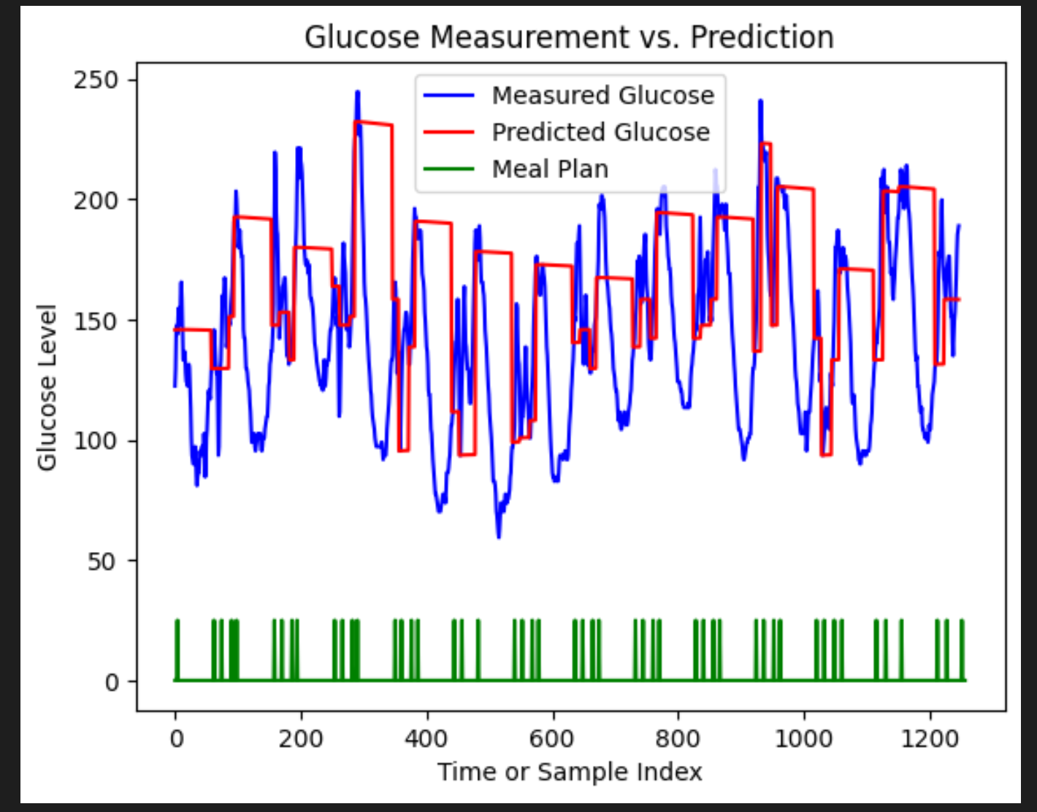

Fig.4 Model Prediction Effect with Initial Parameter Values

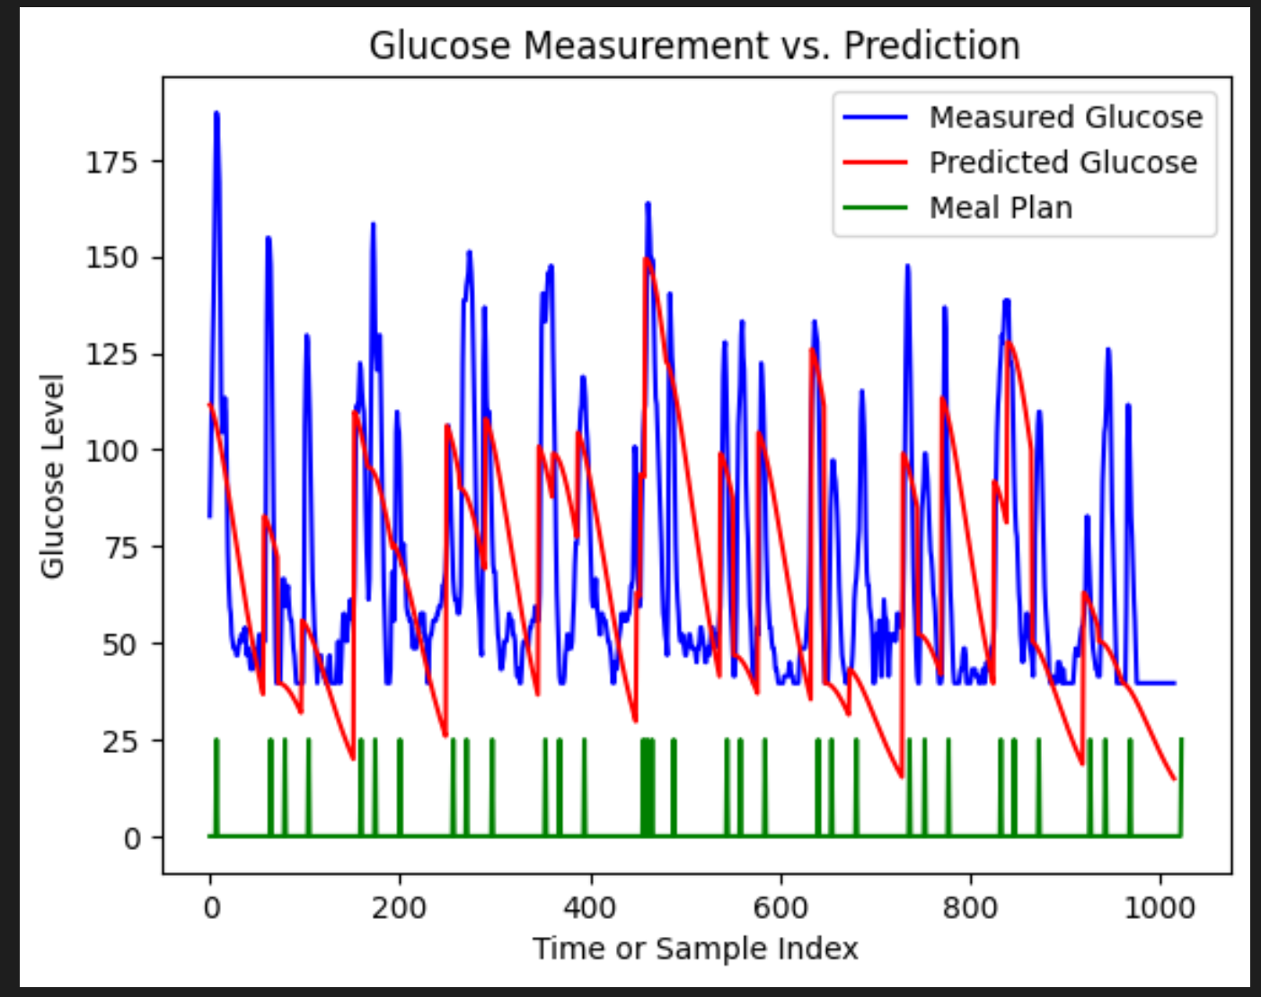

Fig.5 2nd Version of Model Prediction Effect

However, since only one patient’s data is applied for training the model, the effect is still not that ideal. As a result, I apply multiple patient’s data to train the model.

After training with several patients’ data, the model effect is improved to a great degree as is shown in Fig.6.

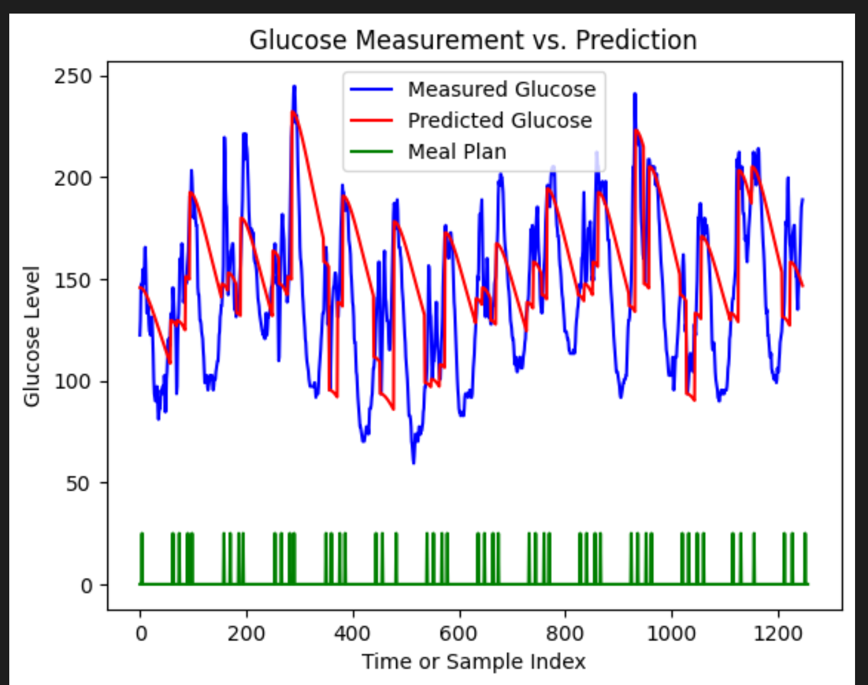

Fig.6 3rd Version of Model Prediction Effect

In the research project, I spent about 18 hours per week on average. During the research process, I develop an understanding of the parameter optimization method in dynamic system. Meanwhile, my skill for writing python code as well as building up a model is improved to a great degree in the practice. Moreover, I am now familiar with the process of doing research, which requires reading articles and finding some innovative ideas, and then conduct these ideas as well as improve them. I need to find possible reasons for some unexpected results and then try to solve them.

**Reference**

Raheb, M. A., Niazmand, V. R., Eqra, N., & Vatankhah, R. (2022). Subcutaneous insulin administration by deep reinforcement learning for blood glucose level control of type-2 diabetic patients. *Computers in Biology and Medicine*, *148*, 105860.

Gábor, A., & Banga, J. R. (2015). Robust and efficient parameter estimation in dynamic models of biological systems. *BMC systems biology*, *9*, 1-25.

**Appendix**

Import Packages

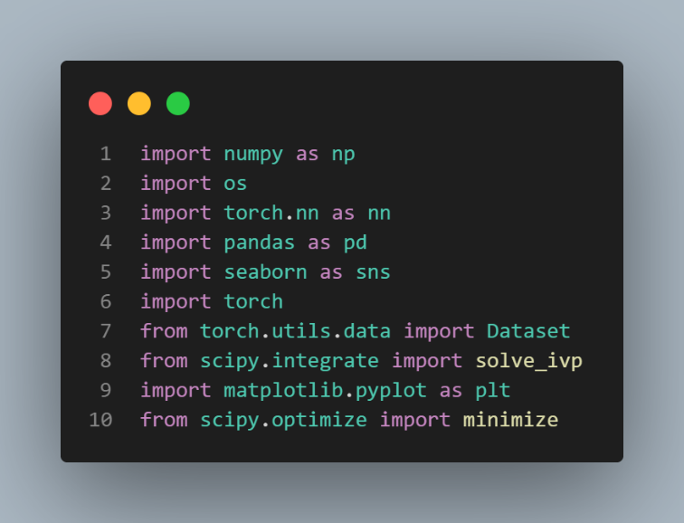

Data Structure

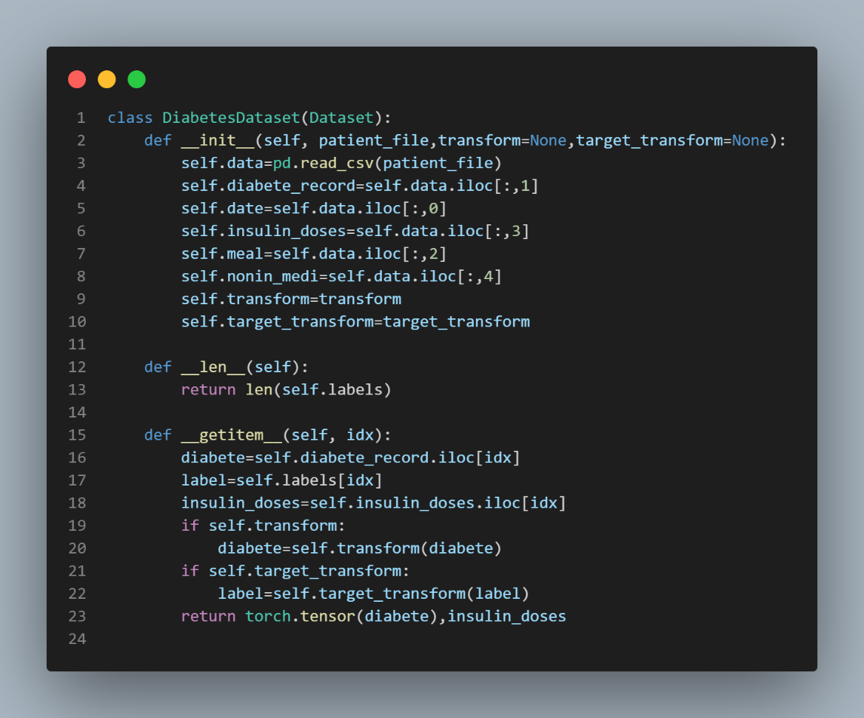

Glucose-Insulin System Definition

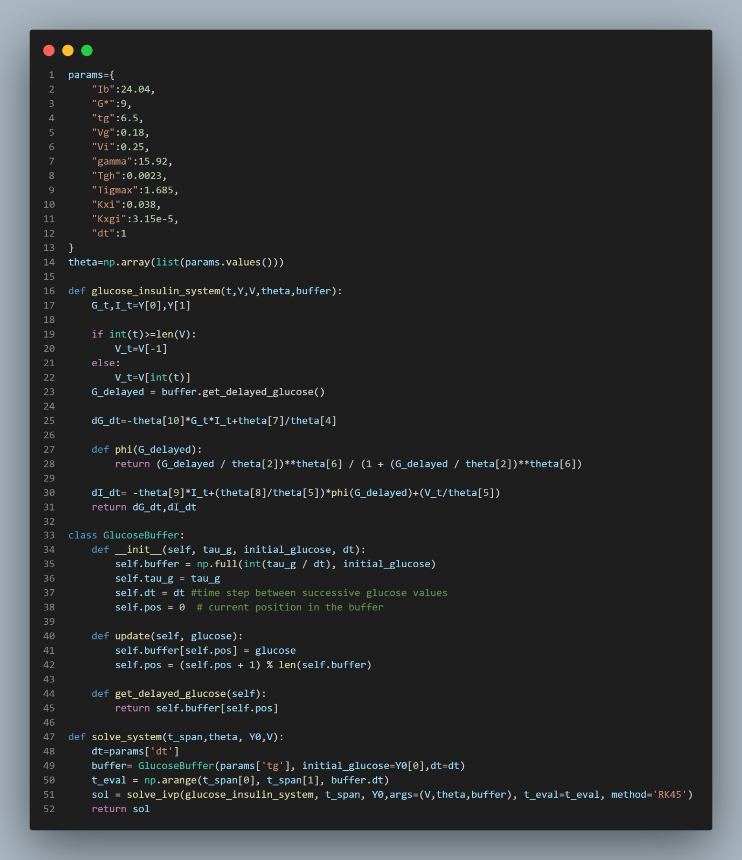

Define Cost Function

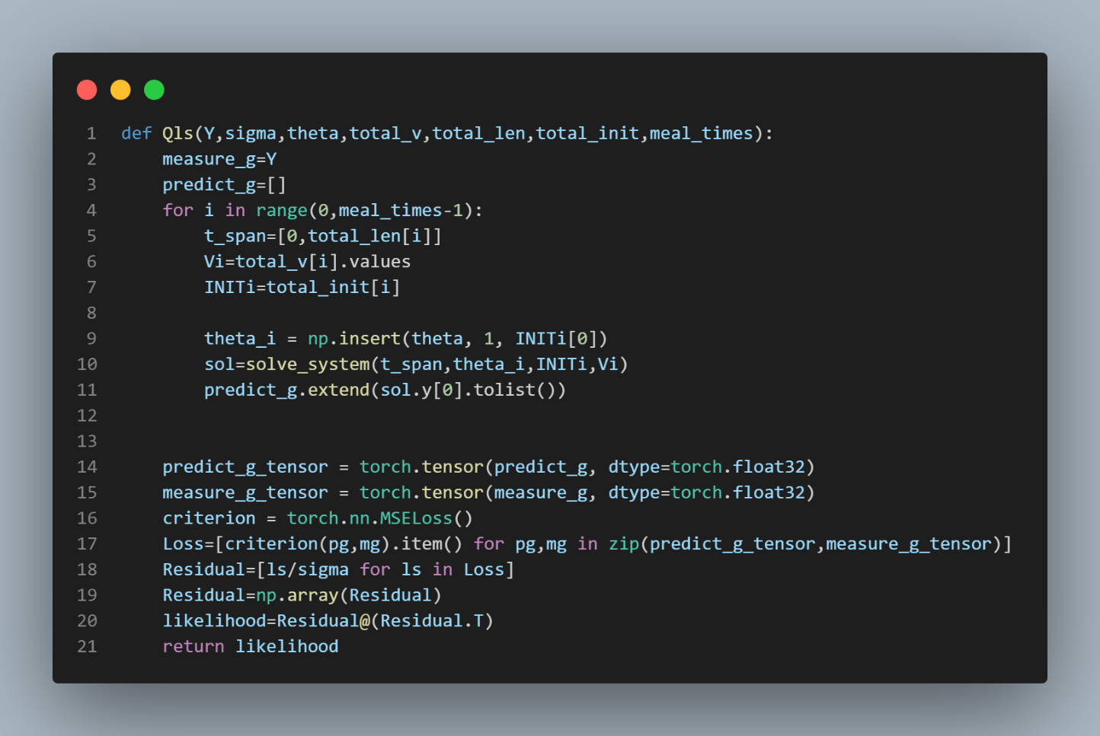

Add Regularization Function and Train

